BRIGHT INNOVATION LIMITED
TECHNICAL PROPOSAL
FOR MATIBABU SACCO LIMITED

1. Project Assumptions

When building the business case for a project, assumptions must be included. Assumptions play a pivotal role in helping project teams and stakeholders set expectations and identify risk mitigation strategies, thus increasing the chances of meeting objectives.
The process of determining accurate assumptions can be time-consuming; this requires experience and a knowledge of the business needs, strengths, and weaknesses. If business constraints are unknown, it's impossible to effectively identify and document assumptions. It's prudent to get input from all stakeholders and key project team members to ensure all bases are
If assumptions are inaccurate, the entire project is put in jeopardy, resulting in wasted time and business resources. If multiple assumptions are incorrect from the start, the desired high-level strategic goals are unlikely to be achievable.
It's critical to monitor assumptions throughout the project in case they turn out to be incorrect or change; if you don't, project failure becomes much more likely. Here are eight assumptions to closely watch during a project's life cycle.
1: Strategy Assumptions.
We assume that Matibabu Sacco have a clear business strategy. We assume that the implementation of the new system will help the organization to achieve some very clear strategic objectives/goals. If projects are undertaken with specific business goals in mind, and those goals don't remain the top focus, then there might be challenges ahead.

2: Resource-level assumptions
Bright Innovations Limited assumes that Matibabu Sacco will allocate adequate resources both material and human to the project. Resources play heavily into the success or failure of a project because a large portion of project management is based on available and allocated resources. If throughout the project, certain resources are overextended or unavailable, it can compromise timelines, task dependencies, and ultimately the entire scope and goal.
Of equal importance is the level of contributions of all resources. Despite the fact that sufficient resources may be allocated, it is still possible to increase project risk if resource contributions are insufficient.
3: Infrastructure -based assumptions
Bright Innovations assumes that Matibabu Sacco will have proper hardware (as recommended in this proposal) in place at the time the project is commencing. We also assume that proper network infrastructure is in place at the time of rollover. Matibabu Sacco will identify any constraints that may exist internally as well as to conduct the necessary due diligence on outsourced technology service providers.
4: Time-Based assumptions
Time based assumptions are impacted by resource availability, technology, quality factors, financial limitations, and other assumptions. We assume Matibabu Sacco will build contingencies and buffers to address all of these assumptions.

HARDWARE REQUIREMENTS

The following table shows the minimum system requirements for Microsoft Dynamics NAV Server.

Operating system | The Microsoft Dynamics NAV Windows client runs on the following versions of Windows:  • Windows 8 Professional or Enterprise (64-bit editions).  • Windows 7 Professional, Enterprise, or Ultimate (64-bit editions).  • Windows Server 2012.  • Windows Server 2008 R2.  • Windows Server 2008 (64-bit editions).  On 64-bit editions of Windows, the Microsoft Dynamics NAV Windows client runs in WOW64 emulation mode.
Hardware resources | Hard disk space:  • 30 MB.  Memory:  • 1 GB.
Additional software | • Microsoft .NET Framework 4.5.  Microsoft Dynamics NAV 2017 Setup installs this software if it is not already present on the target computer.  • Microsoft Lync 2010 or Microsoft Office Communicator 2007 is required for instant messaging and Telephony API (TAPI).  • Microsoft Office 2010 is required for mail merge. Microsoft Office 2010 or Microsoft Office 2007 SP1 is required for Outlook client integration, budget import and export to and from Microsoft Excel and Office XML, and SharePoint links.  - Note Microsoft Dynamics NAV 2017 Setup can only install the Excel Add-in if Excel 2010 is present on the target computer.  • Microsoft Office 2010 is required for OneNote integration. However, OneNote integration is not supported for 64-bit editions of Microsoft Office 2010 running on Windows Server 2008.  • Active Directory and Microsoft Exchange Server 2010 are required for email logging.
Reports | You design and upgrade reports using the Microsoft Dynamics NAV Development Environment. By default, the development environment is installed with the Microsoft Dynamics NAV Windows client. You run reports in the Microsoft Dynamics NAV Windows client or on Microsoft Dynamics NAV Server.  • Microsoft Visual Studio 2010 SP1 Professional, Premium, or Ultimate and Microsoft Report Viewer 2010 SP1 are required for designing reports in the development environment.  Microsoft Dynamics NAV 2016 Setup installs Microsoft Report Viewer 2010 SP1 if it is not already present on the target computer.  • Microsoft SQL Server Report Builder for Microsoft SQL Server 2012 or Microsoft SQL Server 2008 R2 Report Builder 3.0 is required for updating reports in the development environment.  Microsoft Dynamics NAV 2017 Setup installs Microsoft SQL Server Report Builder for Microsoft SQL Server 2012 if none of the above is already installed on the target computer. Setup only installs Microsoft SQL Server Report Builder for Microsoft SQL Server 2012 if the development environment is included in the install.  • Microsoft Report Viewer 2010 SP1 is required for running reports in the Microsoft Dynamics NAV Windows client or on Microsoft Dynamics NAV Server.  Microsoft Dynamics NAV 2017 Setup installs this software if it is not already installed on the target computer.

The following table shows the minimum system requirements for the Microsoft Dynamics NAV Windows client.

Operating system | The Microsoft Dynamics NAV Windows client runs on the following versions of Windows:  • Windows 8 Professional or Enterprise (32-bit or 64-bit editions).  • Windows 7 Professional, Enterprise, or Ultimate (32-bit or 64-bit editions).  • Windows Server 2012.  • Windows Server 2008 R2.  • Windows Server 2008 (32-bit or 64-bit editions).  On 64-bit editions of Windows, the Microsoft Dynamics NAV Windows client runs in WOW64 emulation mode.
Hardware resources | Hard disk space:  • 30 MB.  Memory:  • 1 GB.
Additional software | • Microsoft .NET Framework 4.5.  Microsoft Dynamics NAV 2017 Setup installs this software if it is not already present on the target computer.  • Microsoft Lync 2010 or Microsoft Office Communicator 2007 is required for instant messaging and Telephony API (TAPI).  • Microsoft Office 2010 is required for mail merge. Microsoft Office 2010 or Microsoft Office 2007 SP1 is required for Outlook client integration, budget import and export to and from Microsoft Excel and Office XML, and SharePoint links.  - Note Microsoft Dynamics NAV 2017 Setup can only install the Excel Add-in if Excel 2010 is present on the target computer.  • Microsoft Office 2010 is required for OneNote integration. However, OneNote integration is not supported for 64-bit editions of Microsoft Office 2010 running on Windows Server 2008.  • Active Directory and Microsoft Exchange Server 2010 are required for email logging.
Reports | You design and upgrade reports using the Microsoft Dynamics NAV Development Environment. By default, the development environment is installed with the Microsoft Dynamics NAV Windows client. You run reports in the Microsoft Dynamics NAV Windows client or on Microsoft Dynamics NAV Server.  • Microsoft Visual Studio 2010 SP1 Professional, Premium, or Ultimate and Microsoft Report Viewer 2010 SP1 are required for designing reports in the development environment.  Microsoft Dynamics NAV 2017 Setup installs Microsoft Report Viewer 2010 SP1 if it is not already present on the target computer.  • Microsoft SQL Server Report Builder for Microsoft SQL Server 2012 or Microsoft SQL Server 2008 R2 Report Builder 3.0 is required for updating reports in the development environment.  Microsoft Dynamics NAV 2017 Setup installs Microsoft SQL Server Report Builder for Microsoft SQL Server 2012 if none of the above is already installed on the target computer. Setup only installs Microsoft SQL Server Report Builder for Microsoft SQL Server 2012 if the development environment is included in the install.  • Microsoft Report Viewer 2010 SP1 is required for running reports in the Microsoft Dynamics NAV Windows client or on Microsoft Dynamics NAV Server.  Microsoft Dynamics NAV 2017 Setup installs this software if it is not already installed on the target computer.
NB. Bright Innovations will access available hardware and network infrastructure and give appropriate recommendations.

2. Project Approach

The proposed system Implementation plan/Methodology

The implementation of the proposed solution is based on a proven methodology detailed below:
- Development Plan: - This is the first step as it outlines the parties involved in the project and their responsibilities and clearly states the detailed plan and deliverables expected.(Deliverable – System Development Plan document)
- System Requirement analysis: - This is a key phase as it enables the system developers to thoroughly understand the requirements at a deeper perspective. (Deliverable - System requirements document)
- System design document: - This is a flow chart representation of all processes, there inputs and expected outputs and the workflows that are involved in every processes.
(Deliverable - System Design Document)
- System Development and customization: - This is where the developer do the coding and actual developments based on the requirements (Analysis and Design Documents).
(Deliverable – Developed System).
- Quality Assurance Phase: - this where the processes are counter checked in compliance to the identified standards as well as international standards including security. (Deliverable – Quality Assurance Document).
- Testing Phase: - This is where both the unit testing and user acceptance testing is done. (Deliverable – Test Scripts).
- Training:- These involves all the system users training on operational and functional areas as well as system administrators. (Deliverable – Training Schedule, Training Sign-offs)
- Data extractions and transformation:-This is a phase where the organization’s data from existing records or systems. (Deliverable –Data Transfer Template, Migration Schedules).
- Go Live:- This is the actual use of the system in a production environment
- System support:- This is the onsite support as the users use the system
- Maintenance: - This is where the contract of future support and systems upgrades as well.

Detailed Implementation Plan
Activities | Duration | Deliverables
System Development Plan | 1 Week | System Development Plan document
Systems Analysis | 2 Weeks | System analysis document
Systems Design | 2 Weeks | Design Document
Customization/ Development | 3 Weeks | Systems prototype/ skeleton
Testing | 2 Weeks | Testing Sign offs
Training | 2 Weeks | Training Schedule, Training sign offs
Data Extraction and Transformation | 1 Week | Imported data, Migration Schedules, Opening TB
Go live | 1 day | Operational system
Onsite support | 1 months | Stabilized system
Maintenance |  | Maintenance contract 10%of the systems cost payable after the 1st year.

Change Management

The following scope change management process will be used to ensure that the DYNAMICS NAV Project is managed to the original scope, as will be defined in the development Plan.

Initiate Change:
Any member of the team member may propose a change to the scope of the project. The requester will initiate the process by completing a Change Management Request .
Proposed changes must be approved for investigation by the Project Team Leader prior to investigation of the change and its impact on the schedule and deliverables.
The objective of the Change Request Definition Form is to capture sufficient information to evaluate and act on each proposed change.
Descriptions of the Change Management Request Form follow:
Priority: There are four scope change priority levels:
- Critical: implies that the requester believes that the project cannot proceed unless the change is incorporated, because the change is critical for the success of the project.
- Important: implies that the requester believes there will be significant negative impacts, or major opportunities missed, if the change is not incorporated
- Desirable: implies that the requester believes that the benefits associated with making the change outweigh the costs, but the project can without the change.
- Post-live: implies that the requester would like the change evaluated for inclusion on the project evolution plan (post-live plan)
Description of Proposed Change:
This section provides an explanation of the change described in terms of what it seeks to achieve rather than how it will be implemented. If the proposed change refers to a specific deliverable previously completed, the deliverable should be referenced and appropriate documentation attached to the request form.
Reason for Change (Benefits):
This section explains why the change should be made and must support the priority assessment. It should include the tangible benefits expected if the change is made, who will benefit and in what time frame, and exactly how they will benefit.
Implications of Not Making the Change: This section should specify negative consequences, such as impact on Department care and anticipated lost opportunity costs, for failing to implement the change.
Related Change Request:
This section is particularly important if dealing with a change request investigation. However, other changes come in related clusters, and it may be desirable to highlight these interrelationships or have this change request investigated in conjunction with several others. Bundling several desirable or important priority investigations may generate a critical change recommendation.
Attachments/References: The supporting documentation to assist in understanding the change.

As the above-described information is used to assess whether to spend time and effort investigating the proposed change, it is critical that the requester section data be correct and provides information to allow an estimation of the investigative effort. The Project Team Leader, in conjunction with the Group Leaders, should follow up with the requester and reject the change if insufficient data is provided.

Log and Track Change Request:
A project Change Request Log will be maintained by the administrative support person. It will include the following information for each request:
- Project Change Request Number
- Date Received
- Requester Name
- Priority of Request
- Brief Description of Request
- Name of Project Team Member Investigating the Change
- Current and Final Disposition Status
- Final Disposition Date

All scope change requests will be distributed periodically to the entire team for informational purposes.

Data Migration

- Data migration on financial information

- Chart of accounts is uploaded into the new system in the following format.

No. | Name | Income/Balance Sheet | Account Type | Totaling

- Trial Balance is uploaded into the system – Preferably from the last audited accounts.
- The following schedules are uploaded into the system for the subleger.

No. | Sub ledger | Description
1. | Bank | Bank account schedule is imported into the new system and must balance with the corresponding balance in the G/L
2. | Fixed assets | Assets are imported into the asset register and must report to the respective asset class or group in the G/L. It must balance with respective G/L and totaling assets account.
3. | Debtors | - Loan Accounts – Each loan product will have a Sub-ledger and a G/L Account. This accounts will be set-up and loan schedule uploaded and have to balance with G/L.  - Deposits and Share Capital – Deposits and Share Capital are imported for each member and to the respective sub-ledger and G/L Account.  - Non Member debtors and other investment sub-ledger are imported into the new system  - Schedule for imported sub-ledgers is printed and must tally with the original input  - Member dividend Sub-ledger  - Unpaid Rebates
4. | Creditors | - All Fosa Accounts (Savings, Current, Fixed Deposits etc.) are set-up in the system  - Balances from the above accounts are imported into the system  - Fosa balances must correspond to the respective G/L accounts.  - Non Member creditors and their balances are imported into the system.
5. | Payroll Data | - Payroll Sub-Ledger is set-up and mapped to the G/L  - Staff Bio Data is imported into the system  - Staff Earnings is imported into the system  - Staff Deductions is imported into the system.  - Payroll set-ups is done in new system. This includes PAYE Set-up, NHIF, NSSF, Pension, Payroll Periods  - Leave management set-up in relation to payroll
6. | Inventory Data | - Inventory Set-ups are done  - Item List is uploaded into the system  - Inventory Ledgers are created in the G/L  - Inventory sub-ledger data/Balances are imported

- Data Migration on Human Resource

Human Resource data is imported into the system and covers the following areas.
- Employee Bio Data
- Academic Qualification Data
- Employee Appraisal Data
- Disciplinary Information Data
- Leave Management Data
- Next of kin data
- Staff advances data as well as the advances sub-ledger and the g/l
- Staff documents upload into the system

- Data Migrations on branch operations (Membership)
Member’s data needs to be migrated comprehensively into the new system in order to maintain integrity of the membership data. Therefore, the following data needs to be imported into the new system.
- Member Bio data
- Employment Data
- Next of kin data
- Referees Data
- Fosa Accounts Data
- Documents Uploads

- Data Migration on Credit Module
Loans data management is very important for the overall success of the entire system. This is one of the core areas of operations and data migrations for the credit can be summarized as follows.
- Loan Products
- Each loan has a policy and its parameters needs to be uploaded into the new system. The parameters are; Product Code, Instalments, Interest rate, Loan account, Interest account and many more parameters.
- Loans Bio Data
- Loans bio data may include Loan No, Member No, Member Names, Interest Rate, Installments, Amount Applied, Amount Approved and many more.
- Loan Guarantors
- Details of guarantors are uploaded into the system and attached to the relevant loan number
- Loan Top-ups
- If loan applicant need to clear existing loan with loan under application then the details of the loan to be cleared is captured.
- Repayment Schedule
- Repayment Schedule of all loans needs to be generated as soon as all loan data is in place. This will aid in generating variance reports of actual verses expected
- Appraisal Data
- Appraisal data for salary, Deposits, Share capital and Collateral is uploaded
- Document Management
- All necessary documents are uploaded into the system through document management upload process.
- Data Migration assurance
Checks and balances are put in place to ensure integrity of the entire process. This includes:-
- Trial Balance uploaded must balance and have the same output as the original
- Sub-ledgers must also have the same output as the original
- Bank Reconciliation reports must reconcile with the bank statement

Alignment of Business Process, Controls and Functional Requirements

The following step are used to align business processes, Controls and Functional Requirements;

Design
Process design encompasses both the identification of existing processes and the design of "to-be" processes. Areas of focus include representation of the process flow, the factors within it, alerts and notifications, escalations, standard operating procedures, service level agreements, and task hand-over mechanisms.
Whether or not existing processes are considered, the aim of this step is to ensure that a correct and efficient new design is prepared.
The proposed improvement could be in human-to-human, human-to-system or system-to-system workflows, and might target regulatory, market, or competitive challenges faced by the businesses.
The existing process and the design of new process for various applications will have to synchronize and not cause major outage or process interruption.

Modelling
Modeling takes the theoretical design and introduces combinations of variables. It may also involve running "what-if analysis"(Conditions-when, if, else) on the processes: "What if I have 75% of resources to do the same task?" "What if I want to do the same job for 80% of the current cost?".

Execution
Business process execution is broadly about enacting a discovered and modelled business process. Enacting a business process is done manually or automatically or with a combination of manual and automated business tasks. Manual business processes are human-driven. Automated business processes are software-driven. Business process automation encompasses methods and software deployed for automating business processes.
Business rules have been used by systems to provide definitions for governing behavior, and a business rule engine can be used to drive process execution and resolution.

Monitoring

Monitoring encompasses the tracking of individual processes, so that information on their state can be easily seen, and statistics on the performance of one or more processes can be provided. An example of this tracking is being able to determine the state of a customer order so that problems in its operation can be identified and corrected.
In addition, this information can be used to work with customers and suppliers to improve their connected processes.
The degree of monitoring depends on what information the business wants to evaluate and analyze and how business wants it to be monitored, in real-time, near real-time or ad hoc
Process mining is a collection of methods and tools related to process monitoring. The aim of process mining is to analyze event logs extracted through process monitoring and to compare them with an a priori process model. Process mining allows process analysts to detect discrepancies between the actual process execution and the a priori model as well as to analyze bottlenecks.

Business Process Gaps

Gap Analysis
Any exercise that involves comparing the present state of the business with a conceptual and desired future state, with the objective of “closing the gap” can be called gap analysis.
Gap analysis is not just a one-step process. It involves three stages which can sometimes prove to be somewhat time-consuming and tedious if the improvements to be made are not clear. These three stages include:
- Accurately defining the required changes/future goals:
If you are not clear about the organization’s goals, all your efforts will be in vain. The first and foremost thing to be done is to identify what exactly the goals of the business are and the changes needed to achieve these goals. If the goal is not clear, the improvement exercise will keep on deviating from its desired path.
- Identifying the current scenario and associated issues:
In order to reach ‘where you want to be’, you have to first assess ‘where you stand.’ For example, a failure to see the real reason behind the poor performance of the relevant units of your business may affect profit and growth on the long run. At this stage, the analyst may organize brainstorming sessions, employee interviews, document review sessions to gain insight into present challenges. Only after a comprehensive definition of present challenges can one get a clear picture of the situation.
- Devising the action plan:
Now that you know the present and future expectations, you can think of the how factor, which is in form of a plan. How will you implement the action plan to close the identified gaps? The solutions may include a number of steps like hiring more employees, procuring a new system, offering perks and incentives to get the best out of employees and so on.
It can be inferred that for a business to achieve consistent growth, periodic gap analysis efforts should be encouraged since they play an important role in measuring performance and defining the key activities that need to be completed to attain the desired future state.

Testing

After the code is developed, it is tested against the requirements to make sure that the product is actually solving the needs addressed and gathered during the requirements phase. During this phase unit testing, integration testing, system testing, acceptance testing are done.
Deliverable: Testing Schedules

Training

- Attached to this document

3. Project Team

Project Steering Team

Matibabu Project Manager
Bright Innovations Project Manager
Business/Process Owner
Development/Implementation Team (4)

Project Steering Team

The key stakeholders will be represented by the Steering Team, chaired by the Sacco’s C.E.O.The Steering Team meets to review progress of major milestones and to resolve issues that have been escalated to the Team. Decisions of the Steering Team are final and binding on the Project. All major milestones as well as implementation timetable need to be approved by the Steering Team.
Responsibilities of the Project Steering Team
The main responsibilities of the Implementation Committee are to:
- Actively promote the project as a major initiative towards the implementation of new business process and systems;
- Ensure appropriate resourcing for the project and prioritize conflicting business events;
- Review and sign off deliverables, thereby ensuring that the system/deliverables meet the business requirements;
- Approve the development plan and any subsequent changes thereto, including scope, approach, plans, budget, resourcing, roles & responsibilities, training & implementation strategies, risk profile and quality, change and control procedures;
- Define, address and manage all risks or negative impact to the project;
- Prioritize, approve and manage overall organizational changes and all significant project changes to ensure they are in line with Corporate objectives;
- Formally makes the GO (or NO GO) decision in terms of the relevant criteria at each milestone in the project.

Matibabu Sacco - Project Manager

Roles and Responsibilities of the Sacco Project Manager

- Actively manages all Sacco commitments/deliverables to the project within the timeframe;
- Resolves or escalates issues to the Project Steering Team;
- Monitors the pace of the project in relation to the project schedule
- Responsible for project communication within the business;
- Collates all GO or NO-GO issues and assists the Business Functional owner and project Steering Team with implementation decisions;
- Prepares the project plan and assumes responsibility for the completion of all the tasks relating to the Sacco deliverables, in-line with the project plan schedule;
- Prepares the deployment plan with the Bright Innovations Project Manager.

Bright Innovations - Project Manager

Roles and Responsibilities of the Project Manager

- Prepares a formal project Development Plan against which the implementation will be managed and measured.
- Monitors the project progress and ensures that the Project Steering Team is kept informed on the course of the project and the consequences of change through accurate progress reporting;
- Participates in structuring and planning of the project. He reviews the formal project plan against which the implementation will be managed and measured.
- Communicates and liaises with the Sacco project manager and business owners and thereby monitors/manages expectations and relationships, as well as reporting and participating in the formal project steering meetings, where appropriate;
- Introduces and ensures that formal project management disciplines and manpower from Bright Innovations are provided in time;
- Manages overall project progress and ensures that the implementation is delivered in terms of the approved project implementation charter, thereby satisfying both the business and technical system requirements;
- Involvement in planning and directing solutions to significant implementation risks, issues, concerns, constraints and conflicts. Participation in the GO NO_GO decisions based on customized criteria;
- Participates in establishing the project budget and ensures that sound controls are applied over expenditure;
- Participates in the acquisition and on-going assignments/control of required project resources and ensures adequate attention is applied to team building;
- Conducts regular project progress meetings and prepares required progress reporting.
- He orders the software from Microsoft
- Sole accountability to direct the Sacco activities to ensure Sacco satisfaction;

Business Functional Owner(s)(HODs)

Roles and Responsibilities of the Business Functional Owner

- Preparation and Approval of the questionnaire and requirements;
- Participates as the key ‘stakeholder’ in cross functional business integration decisions;
- Provides resource/s and ensures that a high standard of data preparation is achieved for conversion and implementation cut-over;
- Ensures that appropriate skills and knowledge is developed in the functional area to provide first level support and data management capability.
- Ensures that business operating procedures are updated in line with the new system functionalities;
- Addresses any changes in staff career plans, and updates job objectives accordingly, preferably before implementation;
- Actively markets and promotes the business benefits of the project and pro-actively addresses risks, issues and constraints impacting the project.

Project Implementation Plan
- Attached to this document

5. Third Party Requirements
The following are some of the costs that the institution may incur in the cost of implementation.
- Hardware Costs
- Infrastructure Costs

6. Post Implementation Support

WARRANTIES
- Warranty of software performance; The Developer warrants that for 1 year following acceptance of the of the software by the customer .The software will be free from material reproducible programming error and defects in workmanship and materials, and will substantially conform to the specifications in the development plan when maintained and operated in accordance with the Developer’s instructions. If material reproducible programming errors are discovered during the warranty to customer shall be null and void if the customer is in default under this agreement or the nonconformance is due to;
- Hardware failure due to defects, power problems or any cause other than the software itself.
- Modification of the software operating systems or computer hardware by any party other than the Developer; or
- Misuse, errors or negligence of customer, its employees or agency in operating the software. The Developer shall not be obligated to correct any defects unless customer notifies it at the existence and nature of such defect promptly upon discovery.

PAYMENT OF MAINTENANCE

Customer shall pay Developer for error-correction and support services as well as Microsoft annual enhancement plan after expiry of 1 year free support. Enhancement fee is charged to enable client to do upgrades in future at manageable costs. Any change in maintenance costs will be communicated to the customer in advance.

7. Post Implementation Support

We recommend Microsoft Dynamics Nav – Perpetual License. 7 Full Concurrent Licences will be sufficient unless there is a plan to increase the number of staff. If there is such a plan then we recommend that the sacco can purchase 10 full concurrent license.

8. Bidder Experience
- Available in the main technical document

9. Non-Disclosure or Confidentiality agreement

During the term of the contract agreement and during system maintenance period, Developer will use reasonable cause to prevent the unauthorized use or dissemination of customer’s confidentiality information.
Reasonable can means at least to same degree of cause the Developer uses to protect its own confidential information for unauthorized disclosure.
Confidential information is not limited to information clearly marked as confidential or disclosed orally that is treated as confidential or any other classified information. Confidential information does not include information that;
- The Developer knew before customer disclosed it.
- Is or Becomes public knowledge through no fault of the Developer.
Customer acknowledges that the software is Developers exclusive property. Customer shall treat the software on a confidential basis and shall not, at any time, disclose the trade secrets embodied in the software or supporting documentation to any other person, firm, organization or employee who does not need to obtain access thereto consistent. Compile or reverse assemble the object code contained in the software. Customer shall devote his reasonable best efforts to ensure that all persons accorded access to the software and supporting documentation protect the Developer’s trade secrets against unauthorized use, dissemination or disclosure.

Financial Management

- Chart of Accounts
Chart of account is the core of any organizations financial situation. A well set-up chart of accounts is a pre-requisite to financial reporting. The following are the key aspects of the chart of accounts.
- Chart of account has the format shown below
No. | Name | Income/Balance Sheet | Account Type | Totaling

- Proper Design of the accounts in the chart of accounts will greatly hence how final financial reports can be generated. General layout may look as below.
No. | Name | Income/Balance Sheet | Account Type
Income Statement
1 | Incomes
2 | Expenses
Balance Sheet
3 | Assets
4 | Liabilities

- Each account in the chart of account has a card
- Account in the chart of account can be group into several categories.
- Dimension feature can be used to group different operational activities or Cost Centers e.g. BOSA, FOSA
- Chart of accounts uses Posting Groups to integrate the G/L with sub-ledgers
- General Accounting
Cash/Bank Management
- The system has receipting process. This process enable posting of receipts and generating of a physical receipts.
- The system has a payment process. This process has a workflow for authorization, posting and generation of a payment voucher.
- The system support bank reconciliation process both manual and automated.
Controls management
- The system has controls to ensure that any posting to sub-ledger accounts also updates the G/L.
- Dynamic nav posting is more of preventive than curative. This means that the posting code unit checks and prevent any inconsistencies related to double entry.
- The system has a financial year management mechanism. It allows the user to open and close periods. Once a financial year is closed it cannot be opened again. However, it’s recommended that all accounts are reconciled and data entry confirmed before the financial year is closed.
- Only authorized users can open and close financial period.
- Financial module integrate well with other modules through posting groups. You can create completely new module and integrate with finance and it works seamlessly.
- The system maintains change log that keep trails of everything that is happening at any particular moment in time. This includes insertion, deletion and modification.
- Financial Reporting
The system is able to generate variety of financial reports depending on the consumer and objective of the reporting. All reports are convertible to PDF, Excel and Word formats as well as graphical presentation outputs. Account Schedule feature enables users to easily customize financial reports without assistance by the ICT and the systems provider. The reports includes:-
- G/L Register Report
- Detailed Trial Balance
- G/L Entry Report
- Trial Balance Report
- Balance Sheet Report
- Income Statement Report
- Cash Flow Statement Report
- Periodic Variance Reports
- Bank Reconciliation Report
- Receivables Related Reports
- Payables Related Reports
- Audit Trails and Logs Reports

Sasra Reports
- Capital Adequacy Report – Form 1
- Liquidity Statement Report – Form 2
- Statement of deposit Return – Form 3
- Risk Classification & Provisioning Report – Form 4
- Return on Investments Report – Form 5
- Statement of Financial Position – Form 6
- Statement of Comprehensive Income – Form 7

FOSA Management
FOSA Accounts Set-up
Fosa accounts are set-up based on Sacco policy governing each products. Typically FOSA products are bank products.
FOSA Account Type
- Fosa Set-up
- Account Types
- Account type is the set-up for various types of FOSA Account e.g. Savings, Current and Fixed deposit.
- Format of an account type
No. | Account Type | G/L Account | Interest Rate | Dormancy Period | Interest Account | Minimum Balance | Withdrawal Charges | Excise Duty | Can Link ATM | Maximum  Withdrawal | Account Status | Can  Have  STO | Set Withdrawal Limit
- Account types introduces flexibility in policy on various FOSA Accounts.
- Transaction Types
- Transactions types is used to define operations that are possible for a particular kind of account. E.g. Deposits and withdrawal is possible in a savings account but the withdrawal function is not possible in fixed deposit. You can only transfer to a savings account.

- Fixed Deposit Product Set-up
- Fixed deposit is an investment account
- Fixed deposit has an interest rate based on policy
- Fixed deposit set-up role over and transfer are defined
- Fixed Deposit can be set-up as a collateral
- Fixed deposit communication element (sms and e-mail)
- Fixed Deposit certificate can be printed once a deposit is fixed
- ATM Registration
- This registration process requires a workflow process with enough authorization.
- Account Types set-up allows user to define accounts allowable for M-chai. If it is not allowable then it will not be possible to set-up.
- There must be at least one approval level for this registration to be complete.
- Ability to link ATM Card to the relevant account with proper authorization
- The system is able to issue an ATM Card and subsequently activate it
- System have ability to alert on ATM card expiry and generate new card requisition
- The system has the ability to de-activate an ATM Card when necessary

- Teller & Treasury Management
This is the cash management sub-module of the front office. It is fully integrated to the dynamic nav finance module. It has the following features.
- Cash Accounts Card –Tellers, Treasury
- Each user is assigned a Cashbook.
- Treasury Balance
- Teller Shortage/Overage Feature
- Float Requisition
- Inter Teller Cash Transfer
- Issue to Teller
- Return to Treasury
- Cash Authorisations
- Cheque Deposit
- Electronic Find Transfer

Reports

- Cash Book Detailed Report
- Cash Book Summary Report
- Cashier Report per Teller
- Teller Reports Summary
- Chief Cashier Report
- Chief Cashier Report Daily
- Chief Cashier Report Cheques from Teller
- Chief Cashier Report un-cleared Cheques

- EFT & RTGS COOP Integration
The system can integrate with other systems through XML ports and standard outputs such as CSV, Text and any other formats.
- Standing Orders
Fosa Module allows the account holder to place standing orders for various transactions. The standing orders have the functions as follows.
- Standing orders card
- Placing Standing Orders
- Standing Order Introduction
- Standing Order Recovery
- Standing Order Payment

BOSA Management

Members Management

Member Registration

The system has the sub-Module to manage member application and registration and maintains the following member particulars.

No | Field Name | Remarks
1. | Member Application No | -Automated No. Generation
2. | Member No. | -Automated No. Generation. Can Auto increment from current.
3. | Payroll/Staff No.
4. | FOSA Account No.
5. | File No.
6. | Address
7. | Physical Address
8. | Mobile Phone No.
9. | E-mail address
10. | Identity Card No/Passport No
11. | Gender
12. | Nationality
13. | Registration Date
14. | Activity Code
15. | Member Posting Group | Integration with finance module
16. | Member Status
17. | County, Sub-County, Village
18. | Rejoined
19. | Marital Status
20. | Monthly Contributions
21. | Expected Retirement Date
22. | Photo
23. | Signature
24. | Document Management | -Zetadocs Integration
 | NB. Any other Relevant field can be added

Member Statistics/Information Screen

This simple but very important summary of all member details/transactions with the sacco. If you want to access the current overall status of a particular member then you only need this screen. It has the following details
- Member Personal details(member No, Names, Staff no ,Registration date e.t.c)
- Loan Products – All loan Products taken by a member, BOSA.FOSA and Staff Advances
- Guarantors(Other Members) for loans taken by members
- Loans Guaranteed by Members
- Fosa Accounts – All fosa savings, current and fixed deposit accounts
- Next of Kin

Risk Management

The system provides a flexible mechanism for handling of debts and Calculation of penalties.
- Member loan arrears – Non Payment of loans
- Member loan – Under payment
- Member Dishonoured Cheques
- Penalties Computations
- Loan Categories Management – Perfoming, Watch, Substandard, Doubtful, Loss
- Demand Notices
- Loan Recovery Process

Member Withdrawal/Claims Management

The system has member withdrawal process that is triggered when a member submits request to withdraw from the sacco. The member must provide reason for resignation from the sacco. The Member will be refunded their dues using the formula as illustrated below.

Function | Description | Amount
Add
 | Member Deposits
 | Unpaid Dividends
 | Insurance Fund
 | Funeral Expenses
 | Total
Less | Outstanding Loans (BOSA)
 | Accrued Interest (BOSA)
 | Outstanding Loans (FOSA)
 | Accrued Interest (FOSA)
 | Withdrawal Fees
 | Under/Excess Insurance
 | Total Deductions
 | Net Refund

- Resignation/Withdrawal Process
- Resignation/Withdrawal Slip
- Share Capital Transfer Process
Deceased Cases
- Death Certificate Scanning and Upload into the system
- Funeral Benefits Processing

Member Dividend Management

The system has dividend function that enable processing of dividend using the following methods
- Prorated Method
- Dividend Progression
- Flat Rate Method
Other Feature
- Dividend Computation rate
- Dividend Processing
- Dividend Slip
- Dividend Payment Methods – (FOSA, Bank, Cash, Capitalization)
- Dividend Schedule

Member Reports Management

- Members List
- New Members Report – Per month
- Member per Employer Report
- Member Movement Report
- Member Transfer Report – To Other Saccos
- Member Contributions Summary Report
- Unallocation Contributions to Employers
- Monthly Reconciliation by Employer
- Next of Kin Report
- Member Statement
- Monthly Variance Report
- Monthly Expected Repayment Report
- Member Withdrawal Report

Employer Management

Employer Registration

The system has the sub-Module to manage employer registration and maintains the following employer particulars.

No | Field Name | Remarks
1. | Employer Code | -Automated No. Generation
2. | Employer Name
3. | Employer Posting Group
4. | Employer Postal Address
5. | Business Location
6. | Region
7. | County Name
8. | Sub-County
9. | Telephone No
10. | E-mail address
11. | Business Registration No.
12. | Date of Business Registration
13. | Employer Category (Govt, Religious, Parastatal, NGO, Private)
14. | Payroll Date
15. | Cut-off Date
16. | Employer Status (Active, In-active)
17. | Key Contact Person
18. | Key Contact Phone
19. | Key Contact E-mail
20. | Company Logo
21.. | Signature
22. | Document Management | -Zetadocs Integration
 | NB. Any other Relevant field can be added

b). Employer Reports
- Members List- Specific to employer
- Employer Arrears Reports – On Remittances
- Check off Receipt
- Check-off Advice
- Check-off Report
- Check-off Variance
- Employer Penalties – Delay in remittances or dishonoured cheques
- Unallocation Contributions to Employers
- Monthly Reconciliation by Employer

Loans Management

Loan Application

Loan application maintains basic Bio data about the loan that will be presented in the following format.

Member Details

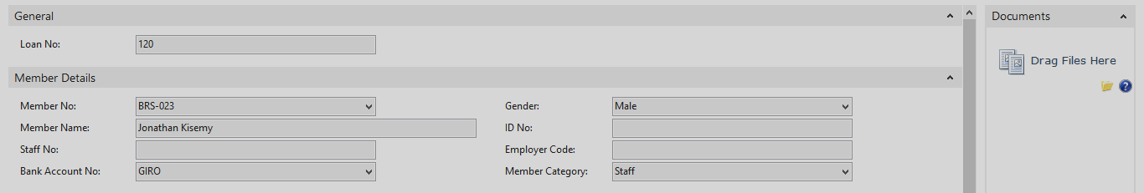

Loan Application Details

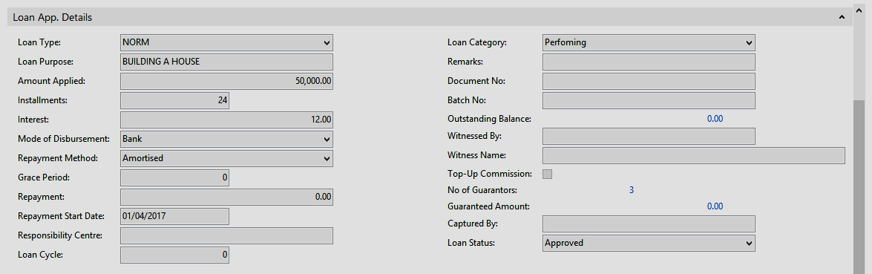

Deposits/Share Capital

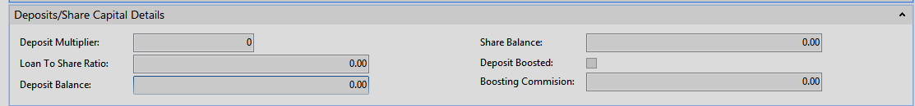

Payslip Details

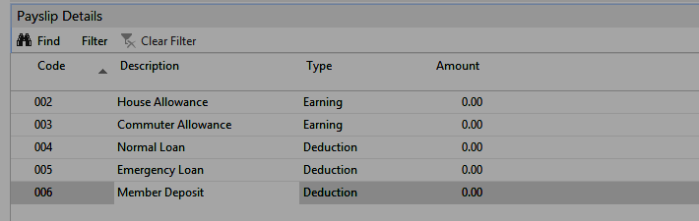

Loan Guarantors

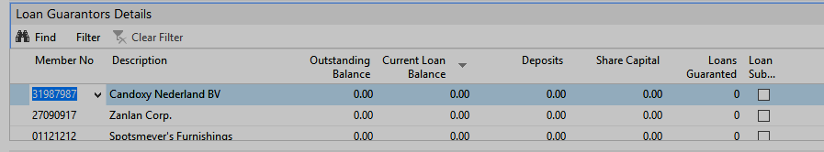

Loan Appraisal

- Apply loan Products Policies
- Salaries appraisal – apply 2/3 Rule
- Guarantor Details
–Includes Active membership
-Shareholding Restrictions
-System allows Guarantor substitution
-Guarantors Auto-charge on default after defined period
-Release guarantor after loan repayment
- Deposits/Share Capital Appraisal
-Loan Multiplier
-Member Deposits analysis
-Share Capital Analysis
-Loan to share ratio

Loan Approval

-Loan Approval Workflow
-Loan Approval Batches
-Loan Disbursement with finance integration
-Recover Loan top-ups
-Recover Loan Charges

Loan Top-ups

- If loan applicant need to clear existing loan with loan under application then the details of the loan to be cleared is captured on the loans top-up window.
- The user selects loan to be recovered
- System computes any accrued interest and updates the top-up window
- The system will also recover any top-up commission if there is any.
- Top-up Commission can be set-up as one of the products parameters in the general set-up
- The system will post the net after top-up principal, interests and commission are fully deducted.
- The actual top-up figures are also available at the appraisal report.
Loan Top-ups/Bridging

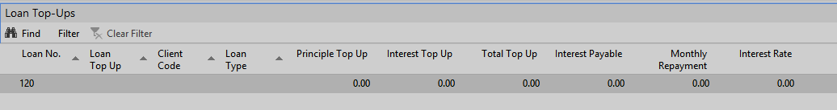

Loan Appraisal Report

Loans Management Reports

- Member Statement
- Loans Register
- Loan Balances Report
- Monthly Variance Report
- Monthly Expected Repayment Report
- Loans Defaulter Aging Report
- Loans Performance Report
- SASRA – Deposit Return Report
- Loans Guaranteed by Defaulters
- Loan Portfolio Report
- Loan Schedule/Actual Report
- Change log entries Report
- Loan Delinquency Report
- Defaulter List to CRB
- Loan Status SMS Report
- Automated Notices to defaulters
- Loan Off-set against Deposits

Guarantor Replacement Card

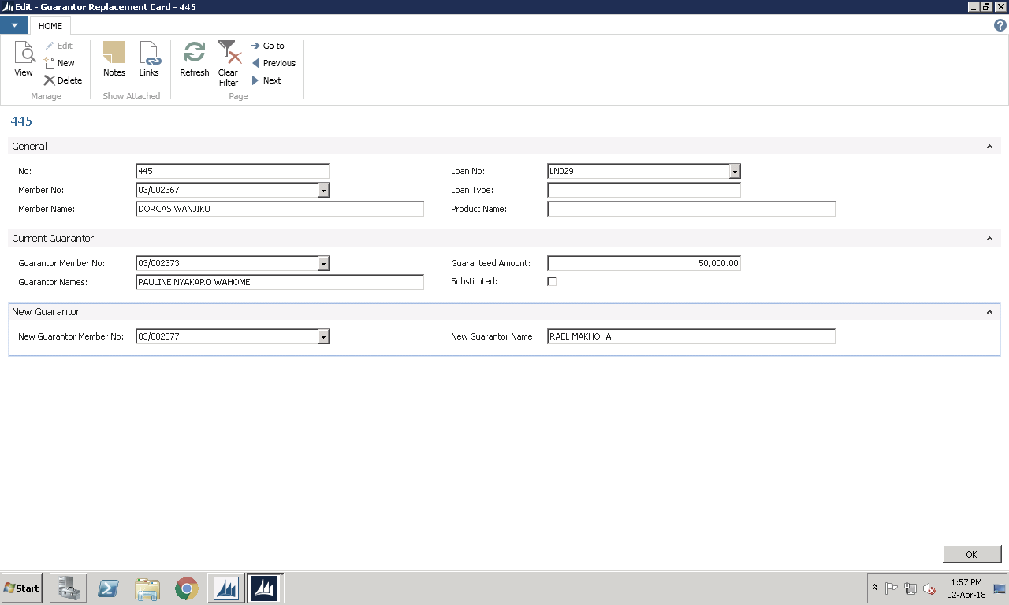

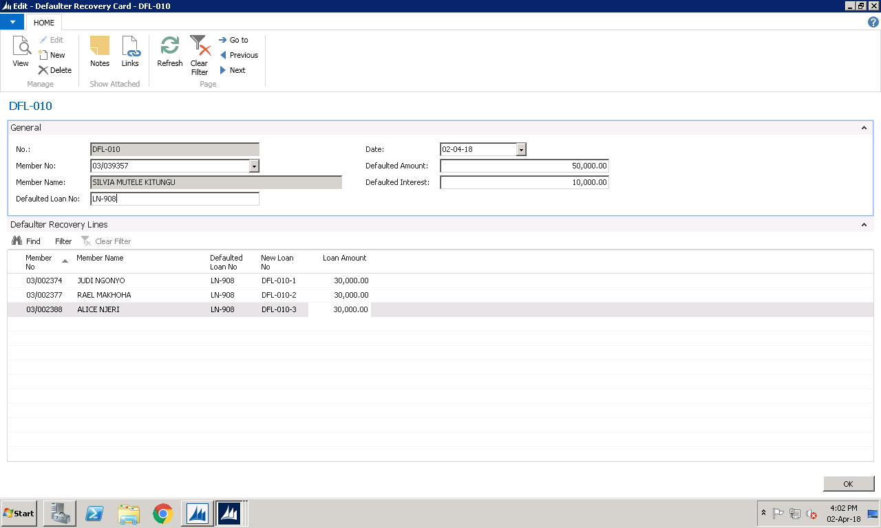
Defaulter Recovery Card

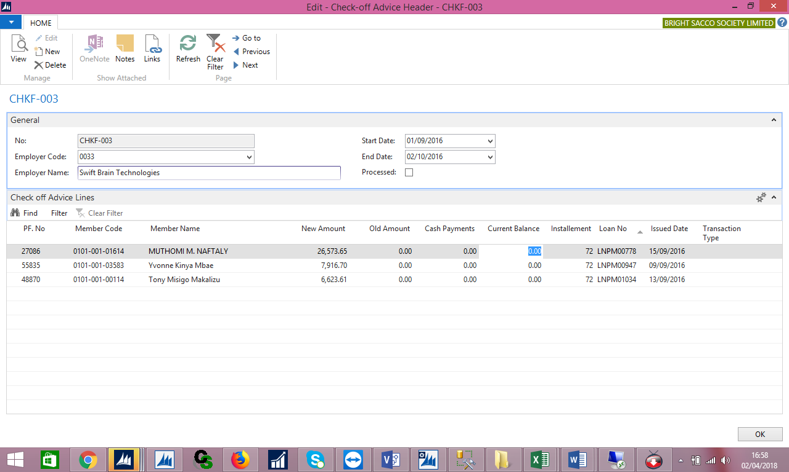
Check-off Advice Card

Datasheet Layout Card-Payroll Advice

PJ/PF .NO | Name | Old Amount | New Amount | Cash Payments | Current Balance
27086 | MUTHOMI M. NAFTALY | 0 | 26,574.00 |  | 0
55835 | Yvonne Kinya Mbae | 0 | 7,917.00 |  | 0
48870 | Tony Misigo Makalizu | 0 | 6,624.00 |  | 0

Member Statistics Card

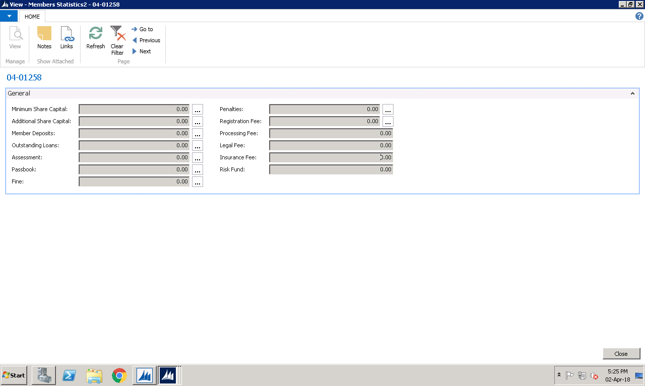

Member Statement Format

- AUDIT MODULE
Microsoft Dynamics Nav sits on MS SQL Server Database. Auditing an instance of the SQL Server Database Engine or an individual database involves tracking and logging events that occur on the Database Engine. SQL Server audit lets you create server audits, which can contain server audit specifications for server level events, and database audit specifications for database level events. Audited events can be written to the event logs or to audit files.
There are several levels of auditing for SQL Server, depending on government or standards requirements for your installation. SQL Server Audit provides the tools and processes you must have to enable, store, and view audits on various server and database objects.+
You can record server audit action groups per-instance, and either database audit action groups or database audit actions per database. The audit event will occur every time that the auditable action is encountered.
The database allows third party audit software to be used to provide additional audit elements and perspectives. Audits provides output reports that can be used for decision making based on audit outcomes.

- Controls
Profiles and Role Centers
Profiles are collections of Microsoft Dynamics NAV users who share the same Role Center. A Role Center is a type of page on which you can place different parts. Each part is a container in which you can host other pages or pre-defined system parts, such as an Outlook part or parts for adding tasks, notifications, or notes.
The user interface of Role Centers and all other pages can be customized. The concept of UI customization in Microsoft Dynamics NAV is divided in two:
- Configuration, performed by the administrator
- Personalization, performed by users

Web Portal
Web Portal enables simple, web-based access to your system. Your corporate information is depicted in the Internet browser as a web application, yet without requiring an infrastructure such as VPN or terminal server.

Web Portal you enhance solution through the addition of a powerful tool that you can vary different scenarios. The possibilities of application are nearly unlimited as almost all of the data pools and processes originating from your system can also be depicted in a web-based manner.

Web Portal Features
Concept and Performance
Maximum Compatibility

Web Portal Functionalities
- Matibabu Sacco Recruitment Processes
- Matibabu Sacco online tendering processes
- Matibabu Sacco Member Web Portal
- Matibabu Sacco Staff self-care portal
- Matibabu Sacco other required processes

Web Portal Self Care
- Instant Loan Applications
- Instant Loan Guarantorship
- Instant Loan Disbursement

NB: ALL OTHER FEATURES ARE COVERED IN THE ADDITIONAL TECHNICAL PROPOSAL

